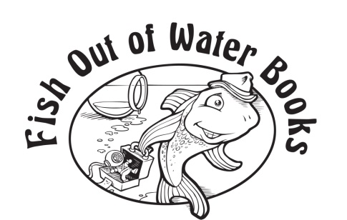

Author Questionnaire

Thank you for your interest in publishing with Fish Out of Water Books.

We like to work in close collaboration, as partners with our authors. We will do our utmost to promote your book, but the more involved you become with the promotion, the more media coverage you can expect, and the better your book will sell.

Please return your completed author questionnaire to fowbooks@gmail.com.

Date:

Title of Book:

Subtitle:

Author’s name as it will appear on the title page:

Address:

Phone:

Email:

Provide a brief author bio, noting any credentials that make you particularly well qualified to write this book. Make it engaging and personable.

Do you have an author website, blog, and/or social media accounts?

How did you come to write this book?

Please provide an overview of the book and a synopsis that could be used for promotional copy.

Please provide a market analysis and describe the target audience(s) for your book.

Are there any specialist groups to which your book would have particular appeal?

Please list 4–5 comparable books (“this book will appeal to fans of ________” e.g.).

Has any part of this book been published elsewhere (in print or online)? If yes, please provide details.

Is this book under consideration for publication elsewhere?

Have you published other books? If yes, please provide title, publisher, year of publication, and the type of book.

Please provide suggestions of authors who might provide blurbs. You do not necessarily need to know any of your suggested authors personally.

List any media—websites, blogs, magazines, newspapers, other media—that should receive a review copy of your book.

Has any article or story of yours attracted particular attention? Please elaborate.

Please list any additional comments or suggestions you have for promotion and publicity:

— Thank You! —

